A Mini Project on

**RESORT BOOKING SYSTEM**

**(NAMASTE WANDERER)**

**BACHELOR OF TECHNOLOGY**

**IN**

**INFORMATION TECHNOLOGY**

*Submitted by*

K.DEVIKA 16121A1261

K.MAANVITHA 16121A1262

L.M.MANJESH 16121A1263

L.NISHANTH 16121A1264

M.CHANDRIKA 16121A1265

M.G.PREETHI 16121A1266

MADHUMITHA AKKARAJU 16121A1267

M.LAHARI 16121A1268

N.THAPASWI 16121A1269



Department of Information Technology

**SREE VIDYANIKETHAN ENGINEERING COLLEGE**

**(AUTONOMOUS)**

(Affiliated to JNTUA, Ananthapuramu, Approved by AICTE, Accredited by NBA & NAAC)

Sree Sainath Nagar, Tirupati – 517 102, A.P., INDIA

**2018 -2019**

**CONTENTS**

**S.NO TITLE PAGE.NO**

Abstract 3

1 Introduction 4

2 Modules 5

3 Concepts Required 6-8

4 Hardware & Software Requirement 9

5 Sample code 10-20

6 Outputs 21-25

7 Conclusion & Future Work 26

References 27

|  |  |  |
| --- | --- | --- |
|  |  |  |

**ABSTRACT**

The project NAMASTE WANDERER speaks about the online system of booking a suit in hotel. This project is designed to override the problems prevailing in the current existing manual system of booking a suit. The project helps to reduce hardships faced by the existing system. The project is implemented in such a way that it carries out the operations in a effective and smooth manner.

The interface of the project is user friendly as the user can find no difficulty in using the website. The project is error-free, secure, reliable and fast management system. Instead of maintaining all the details manually it allows the management to store the in a database which can be retrieved at anytime easily.

Every hotel management systems have different designs of their working system. Therefore this design is implemented in such a ways that it satisfies the managerial requirements. The project is designed to provide service in a strategic planning and ensures that user is provided with right level of information.

**1.INTRODUCTION**

The main objective of this project is to automate the existing manual system by the help of computerized methods and software so that the users data can be stored and accessed easily and save the valuable time.

The project allows the user to book a room, order food online and also to search for any scenic trails nearby. Further it provides the route maps as a guide to reach the places the user wishes to visit. It keeps a record of all the details about bookings, food orders , payments.

**1.1.FUNCTIONALITIES:**

1. Provides the searching facilities for hotels, rooms, food orders, scenic trails.
2. Manages customer details online for booking and payment purpose.
3. Manages the information of rooms availability.
4. Manages the menu for any food orders.
5. Manages the list of places that can be visited nearby.
6. Provides the guidance route maps for the users.
7. Deals with the information and billing of payments.

**2.MODULES**

The project mainly involves two modules. They are:

1.Hotels

2.Restaurants

**2.1.HOTELS:**

This is the first module in the project which helps users in order to sign up into the website and visit the hotel before booking itself. It enables user to visit the entire hotel along with rooms and all facilities inside the hotel so, that it provides user a friendly environment. In this module provides the option to select the room which user want to visit later if user wishes to book the room they can proceed booking procedure from that page itself.

**2.2.RESTAURANTS:**

This is second module in this project which provides customers a easy way to order food items in the hotel website itself. Here also it provides users a flexibility of seeing the item and also reviews regarding the item before ordering it. And if users feel like tasting it they can order it from the website itself.

**3.CONCEPTS REQUIRED**

**3.1.HTML:**

1. <input>Defines an input control

2. <textarea>Defines an multiline input control such as address

3. <button> Defines a clickable button through which we can navigate to other file on click

4. <img>Defines an image to be inserted in html page

5. <a>Defines a hyperlink or displays a hyperlink on page

6. <link>Defines the relation between html and external source, we can

include stylesheets

7. Scripts through link tag.

8. <style>Defines style of the html, used to define backgrounds, fonts, text etc.

9. <script>Defines a client-side script, we can validate a form using script.

10. <div>Defines a section in document, we can divide the html page into

sections using this tag.

11. <span> Defines a section in document, we can apply styles to all

elements present in span.

**3.2.JAVASCRIPT:**

/W/ Defined to check the white spaces in the textbox.

/d/ Defined to check whether the textbox contains only digits.

/[a-z][A-Z]/ Defined to check whether the textbox contains only alphabets.

/^\w+([\.-]?\w+)*@\w+([\.-]?\w+)*(\.\w{2,3})+$/

Defined to check the email address is valid or not.

**3.3.JQUERY:**

Click():The click() method attaches an event handler function to an HTML

element.The function is executed when the user clicks on the HTML element.

Dblclick() :The dblclick() method attaches an event handler function to an HTML

element.The function is executed when the user double-clicks on the HTML element.

Mouseenter(): The mouseenter() method attaches an event handler function to an HTML element.The function is executed when the mouse pointer enters the HTML element

Mouseleave(): The mouseleave() method attaches an event handler function to an HTML element.The function is executed when the mouse pointer leaves the HTML element

Mousedown():The function is executed, when the left, middle or right mouse button is pressed down, while the mouse is over the HTML element.

Mouseup():The mouseup() method attaches an event handler function to an HTML element.The function is executed, when the left, middle or right mouse button is released, while the mouse is over the HTML element.

Hover():The hover() method takes two functions and is a combination of the mouseenter() and mouseleave() methods.

Focus():The focus() method attaches an event handler function to an HTML form field.The function is executed when the form field gets focus.

Blur():The blur() method attaches an event handler function to an HTML form field.The function is executed when the form field loses focus.

**3.4.PHP:**

mysqli_connect() Function:The mysqli_connect() function opens a new connection to the MySQL server.

mysqli_query() Function: The mysqli_query() function performs a query against the database.

mysqli_num_rows() Function: The mysqli_num_rows() function returns the number of rows in a result set.

mysqli_fetch_assoc() Function: The mysqli_fetch_assoc() function fetches a result row as an associative array.

mysqli_close() Function: The mysqli_close() function closes a previously opened database connection.

Session_start():

When you work with an application, you open it, do some changes, and then you close it. This is much like a Session. The computer knows who you are. It knows when you start the application and when you end. But on the internet there is one problem: the web server does not know who you are or what you do, because the HTTP address doesn’t maintain state.Session variables solve this problem by storing user information to be used across multiple pages. By default, session variables last until the user closes the browser. So Session variables hold information about one single user, and are available to all pages in one application.

number_format() Function: The number_format() function formats a number with grouped thousands.

get(): Information sent from a form with the GET method is visible

to everyone.

post(): Information sent from a form with the GET method is not

visible to everyone .

**4.HARDWARE AND SOFTWARE REQUIREMENTS**

**4.1.HARDWARE :**

PROCESSOR 2.4 GHZ PROCESSOR SPEED

MEMORY 2GB RAM

DISK SPACE 500GB

**4.2.SOFTWARE:**

OPERATING SYSTEM WINDOWS

FRONT-END HTML,CSS

BACK-END PHP,MYSQL

**5.SAMPLE CODE**

**5.1.MAIN HTML PAGE :**

<html>

<head>

<title>Terms and Conditions</title>

<style>

h1{

color:white;

}

background-color:black;

}

#d4

{

background-color:rgba(0,0,0,0.1);

z-index:0;

top:350px;

position:absolute;

left:70%;

left:12%;

}

.button{

background-color:black;

font-size:25px;

color:white;

}

#b1

{

background-repeat:norepeat;

z-index:0;

}

body{

background-color:skyblue;

}

b11{

z-index:1;

}

#i1{

position:absolute;

top:50px;

background-color:rgba(0,0,0,0.8);

width:950px;

:rgba(0,0,0,1);

width:1366px;

height:768px;

z-index:1;

left:0%;

) {

var thissound=document.getElementById(soundobj);

thissound.pause();

thissound.currentTime = 0;

}

<p id="ll">please press the calling bell inorder to visit the hotel.</p>

</div>

<pre><h1 style="align:center;font-family:segoe print;color:white;font-size:32px;font-weight:20px;">

please select the room which you like to visit.</h1></pre>

</div>

<div id="bedroom" style="position:absolute;top:1300px;width:1366px;height:768px;">

<div id="i2">

<input type="button" id="p2" name="submit" value="BACK" id="i5" height="20px" style="position:absolute;top:80px;left:8%" onclick='document.location.href="#hall"'>

<imgsrc="bedroom.jpg" width="500px" height="500px" style="position:absolute;top:90px;background-repeat:norepeat;left:31%"></img><br>

</div><br>

</div>

<div id="kitchen" style="position:absolute;top:1900px;width:1366px;height:768px;">

<div id="i2">

<input type="button" id="p2" name="submit" value="BACK" id="i5" height="20px" style="position:absolute;top:80px;left:8%" onclick='document.location.href="#hall"'>

<img src="kitchen.jpg" width="500px" height="500px" style="position:absolute;top:90px;background-repeat:norepeat;left:31%"></img><br>

</div>

</div>

<div id="bathroom" style="position:absolute;top:2500px;width:1366px;height:768px;">

<div id="i2">

<input type="button" id="p2" name="submit" value="BACK" id="i5" height="20px" style="position:absolute;top:70px;left:8%" onclick='document.location.href="#hall"'>

<img src="bathroom.jpg" width="500px" height="500px" style="position:absolute;top:80px;background-repeat:norepeat;left:31%">

<pre><h1 style="align:center;font-family:segoe print;color:white;font-size:32px;font-weight:20px;"> If u like to book room in the hotel please click on BookNow Button.

</h1></pre>

<input type="button" id="p2" name="submit" value="BOOKNOW" id="i5" style="position:absolute;top:580px;left:86%" onclick='document.location.href="register.html"'>

</div>

</div>

</div>

</body>

</html>

**5.2.RESTAURANT PAGE:**

<html>

<head>

<script src="https://ajax.googleapis.com/ajax/libs/jquery/2.1.3/jquery.min.js"></script>

<script src="desktop/js/shop6.js"></script>

</head>

<title>Indian</title>

<style>

body { background:#ccc; margin:10; }

.bg {

position:absolute;

.bg.reveal { -webkit-clip-path:none !important; z-index:2; }

#hea

{

width:1366px;

height:20px;

border:no border;

position:relative;

z-index:10;

float:left;

line-height:28px;

color:black;

font-size:30px;

text-transform:uppercase;

font-family:Tahoma;

letter-spacing:1px;

}

.box {

width:130px;

height:50px;

border:4px solid #fff;

position:relative;

font-family:Tahoma;

letter-spacing:1px;

}

#bg1 {background-image:url('panner.jpg'); background-size:150%}

#bg2 {background-image:url('poha.jpg'); }

#bg3 {background-image:url('veg-pulao.jpg'); }

#bg4 {background-image:url('Rajma.jpg');}

#bg5 {background-image:url('kaali dal.jpg');}

#bg33 {background-image:url('colada.jpg');}

<div class="container">

<div id="hea"

<div id="box8" class="box" data-bg="#bg8">Roti</div>

</br></br></br></br>

<div id="hea" style="text-align:center">NON-VEG</div></br></br>

<div id="hea" style="text-align:left">STARTERS</div></br></br></br>

</br></br></br>

</br></br></br>

<div id="hea" style="text-align:left">MAIN COURSE</div></br></br></br>

<div id="box38" class="box" data-bg="#bg38">FishFingers</div><div id="box39" class="box" style="width:0px;height:0px;border:0px" data-bg="#bg39"></div>

<div id="bg40" class="bg"></div>

</div>

<script src="https://ajax.googleapis.com/ajax/libs/jquery/2.1.3/jquery.min.js"></script>

<script>

$(document).ready(function()

('reveal');

});

});

</script>

</body>

</html>

**5.3.REGISTRATION PAGE:**

<html>

<head>

<title>Registration Page</title>

<link rel="stylesheet" type="text/css" href="user2.css">

</head>

<body>

<div class="login-box"><img src="avatar.png" class="avatar"></img>

<h1>REGISTER HERE</h1>

<p>Mobile number</p><input type="number" placeholder="enter number" required>

<input type="submit" name="submit">

<a href="login.html">ALREADY HAVE AN ACCOUNT</a><br/>

</form>

</div>

</body>

</html>

**5.4.LOGIN PAGE:**

<html>

<head>

<title>Login page</title>

<link rel="stylesheet" type="text/css" href="user.css">

</head>

<body>

<div class="login-box"><img src="avatar.png" class="avatar"></img>

<h1>login here</h1>

<form action="validate1.php" method="post">

<p>username</p><input type="text" name="t1" placeholder="enter username" required>

<p>password</p><input type="password" name="t2" placeholder="enter password" required>

<input type="submit" name="submit">

<a href="register.html">Do not have an account</a><br/>

</form>

</div>

</body>

</html>

**5.5. MAINTAINENCE PAGE:**

<?php

session_start();

$_SESSION['finalPrice']=0;

require_once "test.php";

if(isset($_POST["add_to_cart"]))

{

if(isset($_SESSION["shopping_cart1"]))

{

$item_array_id = array_column($_SESSION["shopping_cart1"], "item_id");

if(!in_array($_GET["id"], $item_array_id))

{

$count = count($_SESSION["shopping_cart1"]);

$item_array = array( 'item_id' => $_GET["id"], 'item_name' => $_POST["hidden_name"], 'item_price' => $_POST["hidden_price"], 'item_quantity' => $_POST["quantity"] );

$_SESSION["shopping_cart1"][$count] = $item_array;

}

else

</head>

<body>

<br />

<div class="container" style="width:700px;float:left;">

<h3 align="center">AVALIABLE INDIAN ITEMS FOR ONLINE ORDERING</h3>

<br />

<?php

$query = "SELECT * FROM myItems ORDER By id ASC";

$result = mysqli_query($conn, $query);

if(mysqli_num_rows($result) > 0)

{

while($row = mysqli_fetch_array($result))

{

?>

<div class="col-md-4">

<form method="post" action="sree.php?action=add&id=<?php echo $row["id"]; ?>">

<div style="border:1px solid #333; background-color:#f1f1f1; border-radius:5px; padding:16px;" align="center">

<img src="<?php echo $row["image"]; ?>" class="img-responsive" style="width:200px;height:100px"/>

<br />

<h4 class="text-info">

<?php echo $row["name"]; ?></h4>

<?php

}

}

?> <br />

</div>

<div float="right" >

<h3>Order Details</h3>

<div class="table-responsive" float="right" style="background-color:white">

<table class="table table-bordered">

<tr>

<th width="40%">Item Name</th>

<th width="10%">Quantity</th>

<th width="20%">Price</th>

<th width="15%">Total</th>

<th width="5%">Action</th>

</tr>

<?php

if(!empty($_SESSION["shopping_cart1"]))

{

$total = 0;

foreach($_SESSION["shopping_cart1"] as $keys => $values)

{

?>

<tr>

<td><?php echo $values["item_name"]; ?></td>

<td><?php echo $values["item_quantity"]; ?></td>

<td> <?php echo $values["item_price"]; ?></td>

<td> <?php echo number_format($values["item_quantity"] * $values["item_price"], 2);

?>

</td>

<td><a href="sree.php?action=delete&id=<?php echo $values["item_id"]; ?>">

<span class="text-danger">Remove</span></a></td>

</tr> <?php

$total = $total + ($values["item_quantity"] * $values["item_price"]);

}

?>

<tr>

<td colspan="3" align="right">Total</td>

<td align="right"><?php echo number_format($total, 2); ?></td>

<td></td>

</tr>

<?php

}

?>

</table> </div><div align="center">

<input type="submit" onclick="<?php $_SESSION['finalPrice']+=$total ?>" >

<input type="submit" style="float:right" value="Continue" onclick='location.href="conte.html" '></div>

</div>

<br />

</body>

</html>

**5.6.VALIDATION PAGE:**

<?php

$conn = mysqli_connect("localhost","root", "", "indian") or die("Failed to connect tp");

$val = mysqli_query($conn,'select 1 from myItems LIMIT 1');

if($val == FALSE)

{$sql="CREATE TABLE myItems(

id INT(6) PRIMARY KEY AUTO_INCREMENT,

name VARCHAR(30) ,

image MEDIUMBLOB,

price int(11))";

mysqli_query($conn,$sql);

mysqli_query($conn,$sql1);

$sql1="INSERT INTO myItems(name, image, price) VALUES ('chicken satay','satay.jpg',390)";

mysqli_query($conn,$sql1);

$sql1="INSERT INTO myItems(name, image, price) VALUES ('chicken wings','wings.jpg',390)";

mysqli_query($conn,$sql1);

$sql1="INSERT INTO myItems(name, image, price) VALUES ('Grilled chicken','grill.jpg',390)";

mysqli_query($conn,$sql1);

$sql1="INSERT INTO myItems(name, image, price) VALUES ('kadai chicken','kadai.jpg',390)";

mysqli_query($conn,$sql1);

$sql1="INSERT INTO myItems(name, image, price) VALUES ('fish biriyani','fishbir.jpg',390)";

mysqli_query($conn,$sql1);

}?>

**5.7.STORING DATA:**

<?php

if(isset($_POST['submit']))

if(!($corp == $pass))

{ echo "<script> alert('Password does not match') </script>";

header("Refresh:0; url=register.html");

}

else{

setcookie("user",$uname);

setcookie("pwd",$pass);

header("Refresh:1; url=login.html");

} }

?>

**6.OUTPUTS**

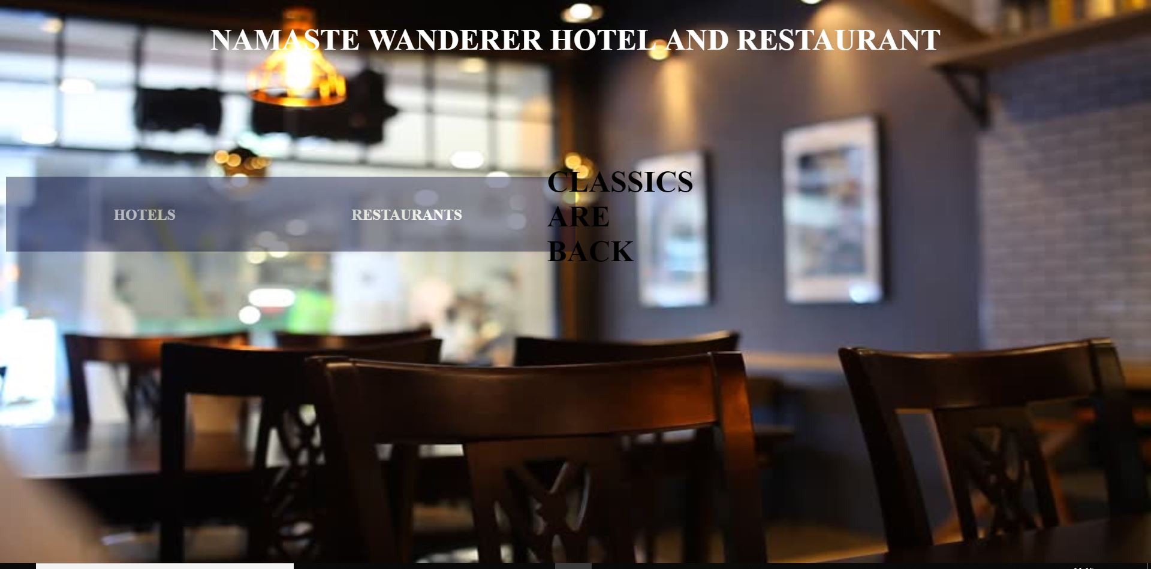

FIG 6.1. The home page of NAMASTE WANDERER online website.

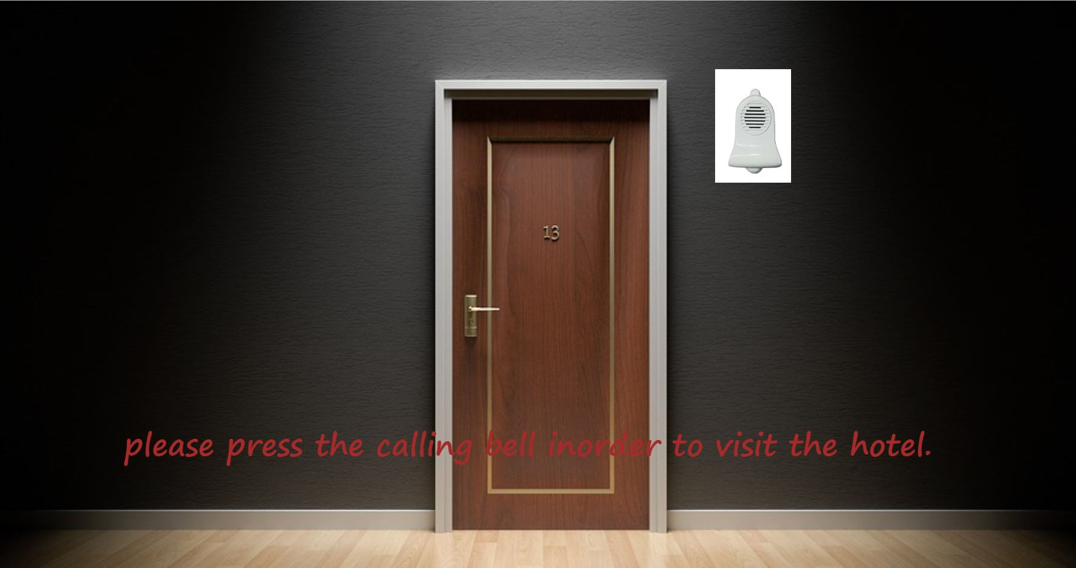

FIG 6.2. The page for visiting the hotel.

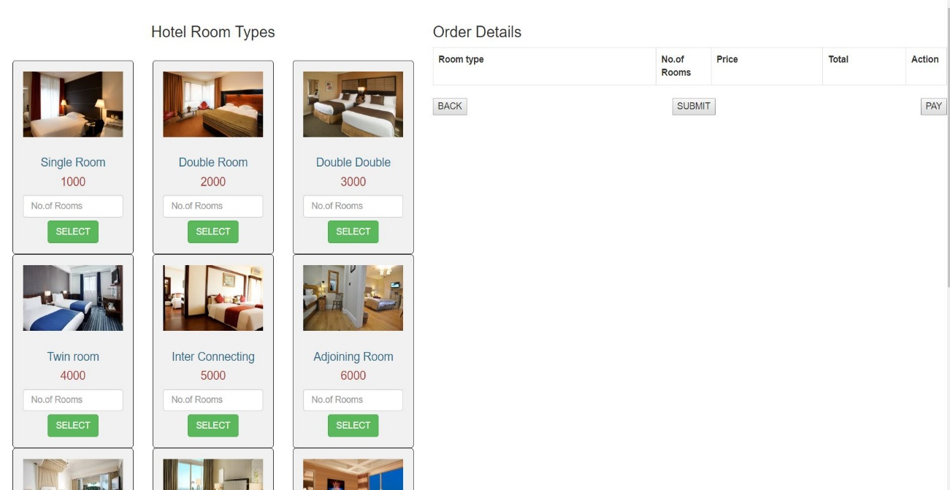

FIG 6.3. For booking the hotel of available types.



Fig 6.4. For booking food online.

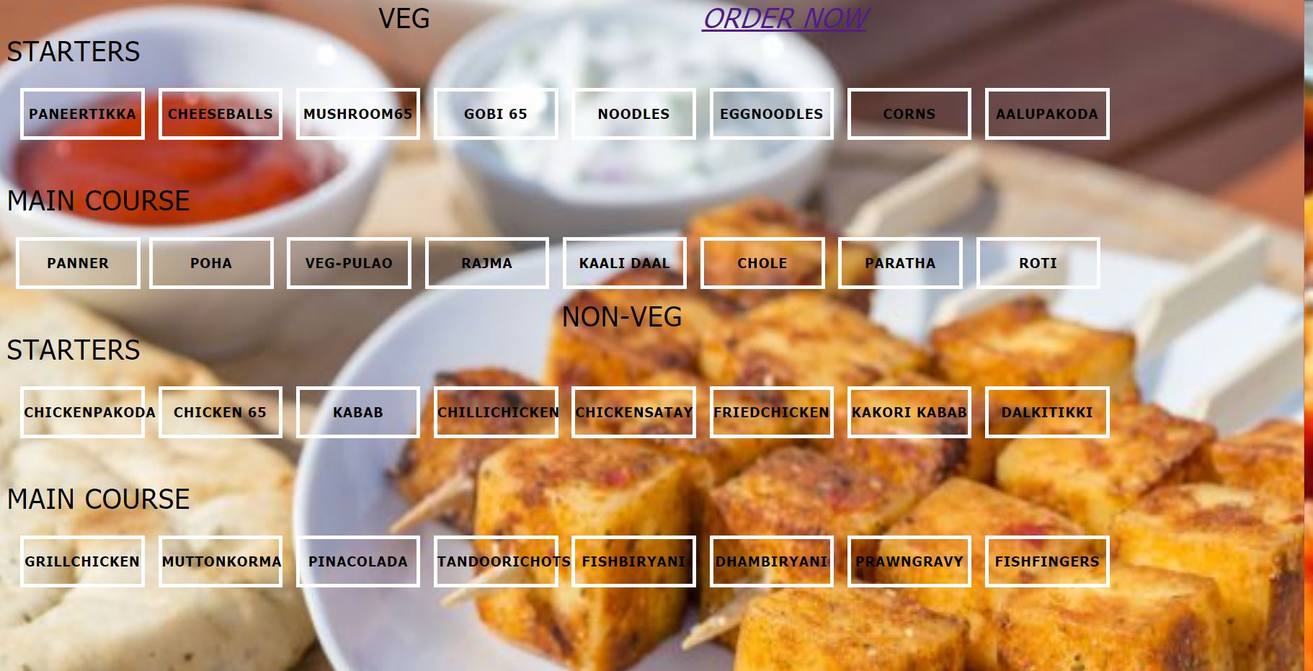

FIG 6.5. The menu for ordering food.

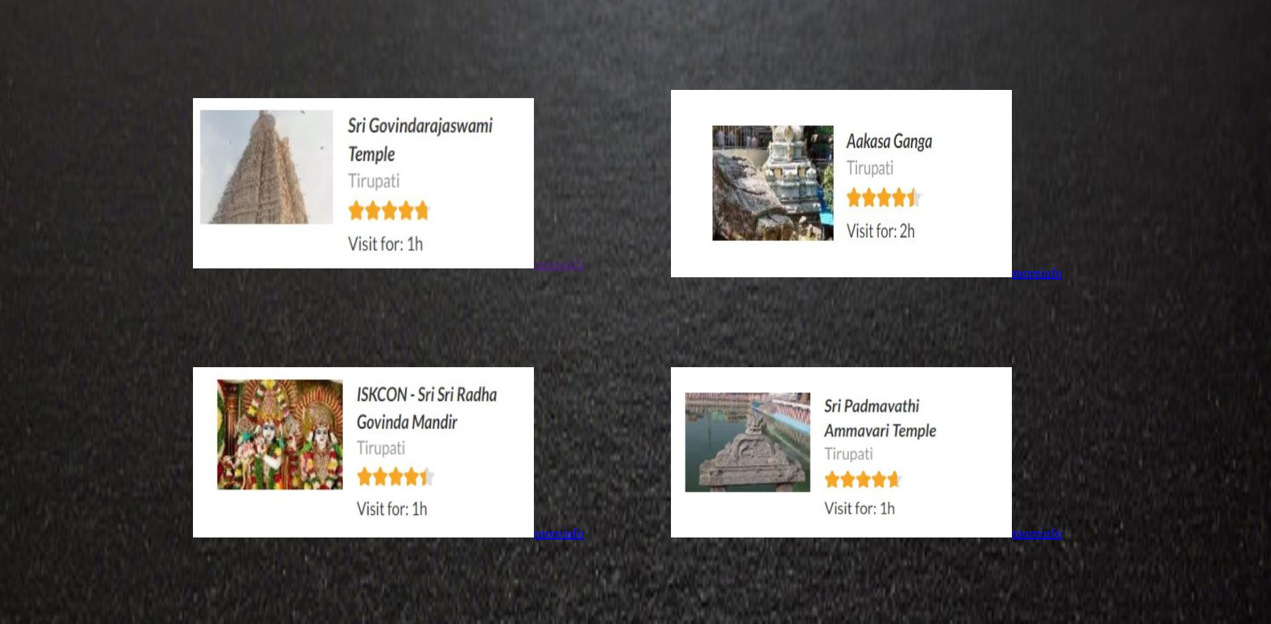

FIG 6.6. For selecting any places nearby to visit.

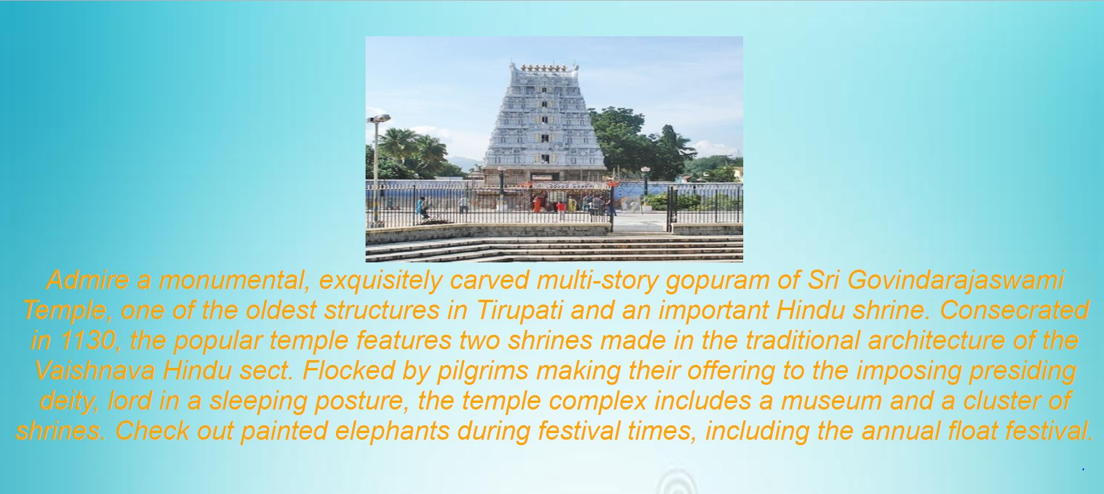

FIG 6.7. Description of the place selected.

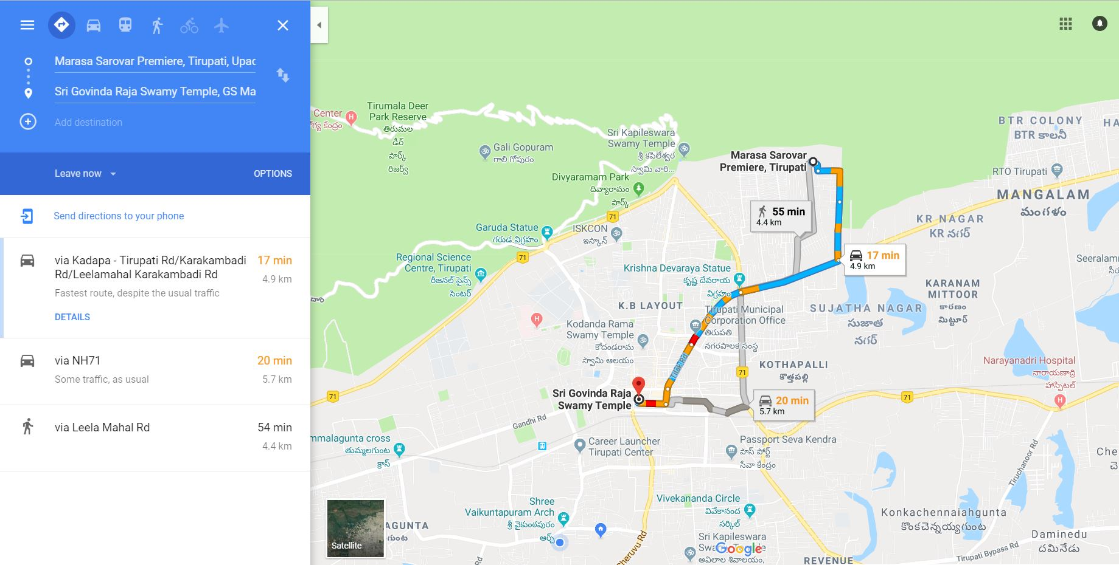

FIG 6.8. Route directions for the selected place using google maps.

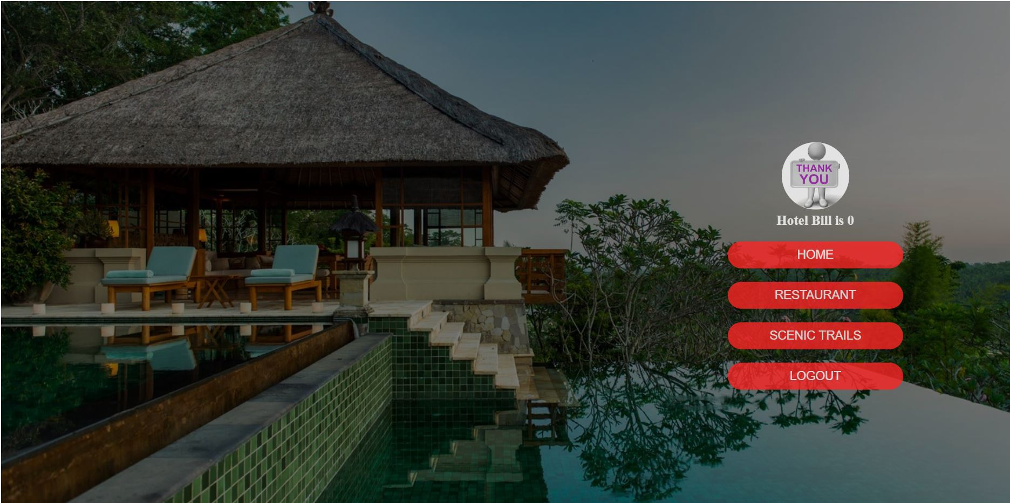

FIG 6.8. The payment and logout page.

**7.CONCLUSION AND FUTURE WORK**

The online resort management has got clear advantage over the manual system. The computerized system is more reliable, efficient and fast at the end of the project, I can say that computer play a very crucial role in the development of firm. All the daily reports generated by the system are to be checked by the concerned official so as to ensure that all the transactions have been put through in appropriate accounts and this is tallied with the new vouchers.

The online management system does maximum work with in minimum time. Because it is used in every field so that it provides comfort and suitability to everyone. Providing maximum facilities and comfort to customers to customers is main goal of the firm.

To achieve this goal, other modern facilities relating to computer should have to be provided.

The project can be further more extended by making NAMASTE WANDERER as one of the finest resorts by providing the customers with more cities to provide the services by making it one of the holiday planning resorts.

**REFERENCES**

1.TEXTBOOK: Thomas A. Powell Tata McGraw Hill, Fifth Edition, 2010.(Ref date :- 11’th October 2018 9:00 A.M)

2.TEXTBOOK: Andrea Tarr, PHP and MySQL, Willy India, First Edition, 2012.(Ref date:- 14’th October 2018 11:00 A.M)

3.HTML 5 : <https://www.w3schools.com/html/html5_webstorage.asp> (Ref date :-1st October 2018 4:00 P.M)

4.PHP [: https://www.tutorialspoint.com/php/php_sessions.htm](:%20https:/www.tutorialspoint.com/php/php_sessions.htm)l (Ref date:- 4th october 2018 6:00 P.M)

5.REFERENCE MODELS [: https://codeclubprojects.org/en-GB/webdev**/**](:%20https:/codeclubprojects.org/en-GB/webdev/) **(Ref date:-17th October 2018 9:00 A.M)**